**Software Framework**

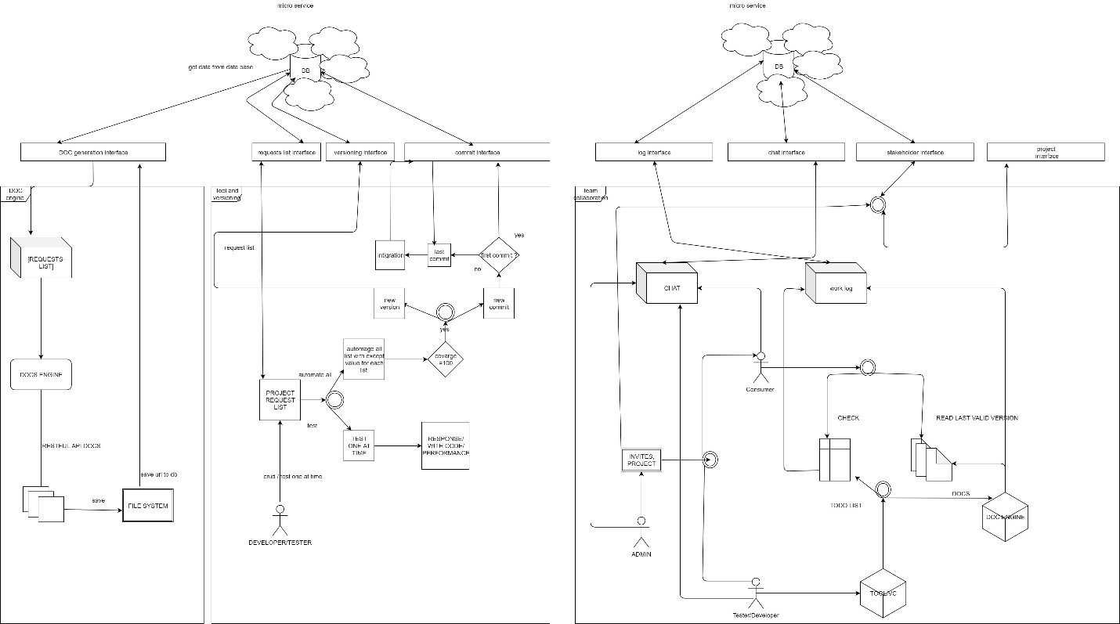

**visit:** <http://94.177.249.33/> to show graph online

The graph contains three diagrams sets the first two represent the core components of the tool, and the third one depends on them.

**Note:** each interface helps to communicate with databases.

Graph components:

1-Documentation generation:

*Documentation generation interface: An api that interacts with the database.

-Requests list: takes a list of requests with their data (body – response – snippets) and pass it to the doc engine.

-Docs engine: takes a requests list and generates the documentation.

-File system: saves the generated documentation using fs to the server and then returns the URL of the file back to the interface.

2-Tool and version control:

*requests list interface

*versioning interface

-Developer/tester can do the following:

1-edit the requests list.

2-test a single endpoint and receiving the response.

3-automate all given tests and generate documentation if the test coverage is 100% and commit the result

* If it’s the first commit it just saves it to the db.
* If it’s not will add the changes to the previous version and make a new commit.

*commit interface

3-Collaboration:

1. Admin tasks:
   1. Can create a new project
   2. Can invite new developers/customers.
2. Developer:
   1. Uses the tool for testing.
   2. Creates the requests list.
   3. Provides info to the doc engine